
Lab Program Number: 34 Date: 20th March,2026
Title: Secure Network Copy using ‘SCP’.

- Copy remote file into local system.
Command:
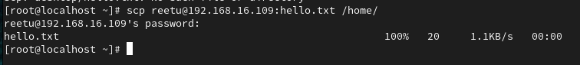
Output:
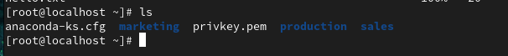

- Copy Local files to the remote host.
Command:
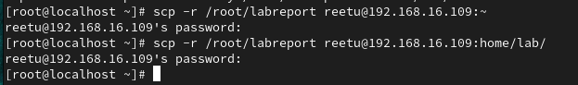
Output:
